|  |
| --- |
| **FRONT END ENGINEERING-II /**  **ARTIFICIAL INTELLIGENCE and MACHINE LEARNING**  Project Report  Semester-IV (Batch-2022)  EmoSense: Real-Time Facial Emotion Detection and Analysis        **Supervised By: Submitted By:**  Ms. Shagun Sharma Honey Bansal-2210990416  Ishan Sharma-2210990420  Ishpreet Singh-2210990425  Jai Chopra-2210990427        **Department of Computer Science and Engineering**  Chitkara University Institute of Engineering & Technology, Chitkara University, Punjab |

# ABSTRACT

# This project presents an innovative system designed to detect and analyze facial expressions in real-time, employing advanced Artificial Intelligence and Machine Learning techniques. The primary objective is to develop a robust model capable of accurately identifying and interpreting human emotions from live video streams. The system's architecture integrates cutting-edge computer vision algorithms and deep learning methodologies, enabling rapid and precise recognition of facial expressions. Additionally, we introduce a sophisticated analysis module that not only identifies emotions but also evaluates their intensity and temporal dynamics.

# Our methodology involves preprocessing raw image data to extract facial features, followed by training a convolutional neural network (CNN) on labeled datasets to recognize specific

# expressions. The trained model is then deployed to analyze live video streams, continuously updating its predictions as new frames are received. The system's real-time capabilities are facilitated by optimized algorithms and parallel processing techniques, ensuring low latency and high throughput.

# 

# To evaluate the system's performance, we conducted extensive experiments using diverse datasets encompassing a wide range of demographics and environmental conditions. Our

# results demonstrate the system's robustness and accuracy across various scenarios, including different lighting conditions, facial orientations, and emotional intensities. Furthermore, we compare our approach with existing methods, highlighting its superior performance in terms of both accuracy and computational efficiency.

# The implications of this work extend beyond technological innovation, with potential applications in fields such as human-computer interaction, affective computing, and psychological research. By providing real-time insights into human emotions, our system opens

# new avenues for enhancing user experiences xin interactive systems and facilitating deeper insights into human behavior and psychology.

# In conclusion, this project represents a significant advancement in emotion recognition technology, offering a reliable and efficient solution for real-time facial emotion detection and analysis. The proposed system's versatility and accuracy pave the way for its integration into various applications, promising to revolutionize the way humans interact with technology and each other.

# 

# 

# TABLE OF CONTENTS

|  |
| --- |
| 1. Introduction  2. Problem Definition and Requirements  3. Proposed Design / Methodology  4. Results  5. References |

# 

# 

# INTRODUCTION

## 1.1 BACKGROUND

## Understanding human emotions plays a pivotal role in various aspects of human interaction, from social interactions to user experience design in technology. Emotion recognition, particularly from facial expressions, has emerged as a crucial area of research with applications spanning human-computer interaction, psychology, healthcare, and beyond. However, accurate and real-time emotion recognition presents significant challenges. Facial expressions are highly dynamic and can vary widely across individuals, cultures, and contexts. Traditional approaches to emotion recognition relied on

manual feature extraction and classification algorithms, which often struggled to capture the nuanced complexities of human emotions.

Recent advancements in Artificial Intelligence (AI) and Machine Learning (ML), particularly deep

learning techniques have revolutionized the field of emotion recognition. Convolutional Neural Networks (CNNs) and recurrent neural networks (RNNs) have shown remarkable success in automatically learning discriminative features from raw data, leading to significant improvements in emotion recognition accuracy and efficiency. Despite these advancements, several challenges persist. Real-time emotion detection from live video streams requires not only high accuracy but also low latency and robustness to environmental factors such as lighting conditions and occlusions. Additionally, existing emotion recognition systems often lack adaptability to diverse cultural contexts and individual differences in facial expressions.

Motivated by these challenges, our project aims to develop a real-time facial emotion detection and analysis system that addresses the limitations of existing approaches. By leveraging state-of-the-art AI and ML techniques, we seek to create a system capable of accurately identifying and interpreting human emotions in diverse real-world scenarios. Our goal is to not only enhance the accuracy and efficiency of

emotion recognition but also to provide insights into the intensity and temporal dynamics of emotions, thus advancing our understanding of human behavior and psychology.

In the following sections, we will describe the methodology used to develop our system, present experimental results demonstrating its performance, and discuss the implications of our findings for future research and applications.

## 1.2 OBJECTIVE

* **High Accuracy:** Develop a robust model that can accurately classify a wide range of facial expressions, including subtle nuances and variations in emotion intensity.
* **Real-Time Processing:** Implement efficient algorithms and techniques to ensure low latency and real-time processing of live video streams, enabling instantaneous emotion detection and analysis.
* **Robustness to Environmental Factors:** Design the system to be resilient to environmental factors such as varying lighting conditions, occlusions, and facial orientations, ensuring consistent performance across diverse real-world scenarios.
* **Adaptability:** Incorporate mechanisms for adaptability to diverse cultural contexts and individual differences in facial expressions, enhancing the system's generalizability and applicability across different populations.
* **Insights into Emotion Dynamics:** Develop an analysis module that provides insights into the temporal dynamics of emotions, including changes in intensity over time and correlations with external stimuli.
* **Validation and Evaluation:** Conduct extensive experimentation and validation to assess the system's performance across diverse datasets and real-world scenarios, comparing it with existing methods and benchmarks.
* **User-Friendly Interface:** Develop an intuitive and user-friendly interface for the system, allowing easy integration into existing applications and facilitating interaction with end-users.
* **Scalability and Efficiency:** Design the system to be scalable and efficient, capable of handling large volumes of data and accommodating future updates and expansions without compromising performance.

# 

# 2. PROBLEM DEFINITION AND STATEMENT:

## 2.1 PROBLEM STATEMENT:

# Emotion recognition technology has made significant strides in recent years, yet several key challenges persist in the field, hindering its widespread adoption and effectiveness. These challenges include:

# Ambiguity in Facial Expressions: Human emotions are complex and nuanced, often expressed through subtle variations in facial expressions. Existing emotion recognition systems struggle to accurately interpret these nuances, leading to misclassifications and inaccuracies in emotion detection.

# Real-Time Processing Constraints: Many emotion recognition systems are computationally intensive, resulting in delays and latency issues that impede their ability to perform real-time analysis of live video streams. This limitation restricts their applicability in time-sensitive scenarios where immediate feedback is crucial.

# Limited Robustness to Environmental Factors: Environmental variables such as lighting conditions, background clutter, and occlusions can significantly impact the performance of emotion recognition systems, leading to decreased accuracy and reliability in real-world settings.

# Cultural and Individual Variability: Emotion expressions can vary widely across different cultures and individuals, posing challenges for emotion recognition systems to generalize across diverse populations. Existing models often lack the adaptability to account for these cultural and individual differences, resulting in biased or inaccurate predictions.

# Insufficient Insights into Emotional States: While existing systems excel at detecting static facial expressions, they often fall short in providing insights into the temporal dynamics of emotions. Understanding the evolution of emotional states over time is essential for gaining deeper insights into human behavior and psychology.

# 

## 2.2 REQUIREMENTS:

### 2.2.1 Software Requirements:

# Python: For data preprocessing, modeling, and evaluation.

# Libraries: OpenCV, TensorFlow, Keras, and NumPy will be utilized for computer vision, deep learning, and data processing tasks.

# Additional libraries for data manipulation, visualization, and machine learning include:

# o pandas: For data manipulation and analysis.

# o numpy: For numerical computing and array operations.

# o matplotlib: For creating static, interactive, and animated visualizations in Python.

# o seaborn: For statistical data visualization based on matplotlib.

# 

# Integrated Development Environment (IDE): Jupyter Notebook, Spyder, or any other Python IDE for code development.

# Text Editor: Any text editor for writing documentation and reports (e.g., Microsoft Word, Google Docs).

### 2.2.2 Hardware Requirements:

# Minimum hardware requirements:

# · CPU: Intel Core i5-8300H or AMD Ryzen 5 3500U.

# · RAM: 16GB DDR4.

# · GPU (optional for accelerated processing): NVIDIA GeForce GTX 1660 Ti or AMD Radeon RX 5600M.

# · Storage: 256GB SSD.

# Recommended hardware for optimal performance:

# · CPU: Intel Core i7-10750H or AMD Ryzen 7 5800H.

# · RAM: 32GB DDR4.

# · GPU: NVIDIA GeForce RTX 3070 or AMD Radeon RX 6700M.

# · Storage: 512GB NVMe SSD.

# 

# 3.PROPOSED DESIGN/METHODOLOGY:

## 3.1 DATASET

# Images or Video Frames:

# · The dataset will consist of images or video frames containing human faces displaying various emotions. Each image/frame serves as a sample for training, validation, or testing the emotion recognition model.

# Emotion Labels:

# · Each image/frame will be labeled with the corresponding emotion expressed by the person in the image. Common emotion labels include:

# · Happy

# · Sad

# · Angry

# · Surprise

# · Fear

# · Disgust

# · Neutral

# 

# Link-><https://www.kaggle.com/datasets/ananthu017/emotion-detection-fer/code>

# 

# 

# 

# 

# 

# 

# 

# 

# 

## 3.2 SCHEMATIC DIAGRAM:

### 3.2.1 Overall Architecture

# 

# +---------------------+

# | Input Data |

# +---------------------+

# |

# |

# +---------------------+

# | Preprocessing |

# +---------------------+

# |

# |

# +---------------------------+

# | Feature Extraction |

# +---------------------------+

# |

# |

# +---------------------------+

# | Emotion Recognition |

# +---------------------------+

# |

# |

# +-------------------------+

# | Post-processing |

# +-------------------------+

# |

# |

# +---------------------+

# | Output |

# +---------------------+

# 

# 

# In the first diagram, the overall architecture of the facial emotion detection system is illustrated. The input data undergoes preprocessing, including face detection and alignment, followed by feature extraction using a convolutional neural network (CNN). The extracted features are then fed into an emotion recognition module, which predicts the emotion expressed in the input image. Finally, post-processing steps may be applied to refine the predictions before generating the output.

# 

### 3.2.2 Detailed Model Architecture:

# +--------------------------------------+

# | Input Image |

# +--------------------------------------+

# |

# +----------------------------+

# | Convolutional Neural Network |

# +----------------------------+

# |

# +----------------------------+

# | Fully Connected Layers |

# +----------------------------+

# |

# +----------------------------+

# | Softmax Layer |

# +----------------------------+

# |

# +--------------------------------------+

# | Predicted Emotion |

# +--------------------------------------+

# 

# 

# In the second diagram, a detailed model architecture is depicted. The input image is passed through a CNN, which learns hierarchical features relevant to emotion recognition. The output of the CNN is flattened and passed through fully connected layers to capture higher-level representations. Finally, a softmax layer produces the probability distribution over different emotion categories, resulting in the predicted emotion.

# 

# 

# 

### 3.2.3 File Structure:

# facial_emotion_detection/

# │

# ├── data/

# │ ├── raw/

# │ │ ├── images/

# │ │ └── annotations.csv

# │ ├── processed/

# │ └── models/

# │

# ├── notebooks/

# │ ├── data_exploration.ipynb

# │ ├── preprocessing.ipynb

# │ └── model_training.ipynb

# │

# ├── src/

# │ ├── data_processing.py

# │ ├── model.py

# │ └── train.py

# │

# ├── utils/

# │ ├── visualization.py

# │ └── evaluation.py

# │

# ├── requirements.txt

# ├── README.md

# └── LICENSE

# 

# 

# 

# 

# 

# METHODOLOGY

# Data Collection:

# Gather a diverse dataset of images or video frames containing human faces displaying various emotions. Ensure proper annotation of emotion labels for each sample in the dataset.

# Data Preprocessing:

# Perform preprocessing tasks such as face detection and alignment to ensure consistency in facial orientations and sizes across the dataset.

# Normalize and standardize the pixel values of the images to improve model convergence and performance.

# Feature Extraction:

# Extract relevant features from the preprocessed images using techniques such as convolutional neural networks (CNNs) or pre-trained feature extractors.

# Optionally, extract additional facial landmarks or keypoints to augment the feature set and capture finer details of facial expressions.

# Model Training:

# Train a deep learning model (e.g., CNN) using the preprocessed images and corresponding emotion labels from the dataset.

# Design the architecture of the model to incorporate layers for feature extraction, spatial hierarchies, and emotion classification.

# Utilize techniques such as transfer learning or fine-tuning with pre-trained models to expedite training and improve performance.

# Model Evaluation:

# Evaluate the trained model using separate validation and testing datasets to assess its performance and generalization ability.

# Measure performance metrics such as batch loss and accuracy to quantify the model's effectiveness in emotion recognition.

# Hyperparameter Tuning:

# Fine-tune model hyperparameters (e.g., learning rate, batch size, optimizer) based on performance feedback from the validation dataset to optimize model performance.

# Analysis and Interpretation:

# Analyze the model's predictions and misclassifications to gain insights into its strengths and weaknesses.

# Visualize model outputs and decision boundaries to understand its behavior across different emotion categories and input variations.

# Deployment and Integration:

# Deploy the trained model into a real-time or batch processing environment suitable for the intended application.

# Integrate the model into existing systems or develop user interfaces for interaction and usability.

# Continuous Improvement:

# Monitor the performance of the deployed model in real-world scenarios and collect feedback for iterative improvements.

# Regularly update the model with new data and retrain it to adapt to evolving user needs and environmental conditions

# 

# 

# 

# RESULT

# 

**PRINTS THE IMAGE ARRAY IN THE FORM OF MATRIX**

**SHOW DIMENSIONS IN THE FORM OF HEIGHT,WIDTH AND CHANNELS**



**SHOW IMAGE FROM IMG_ARRAY**

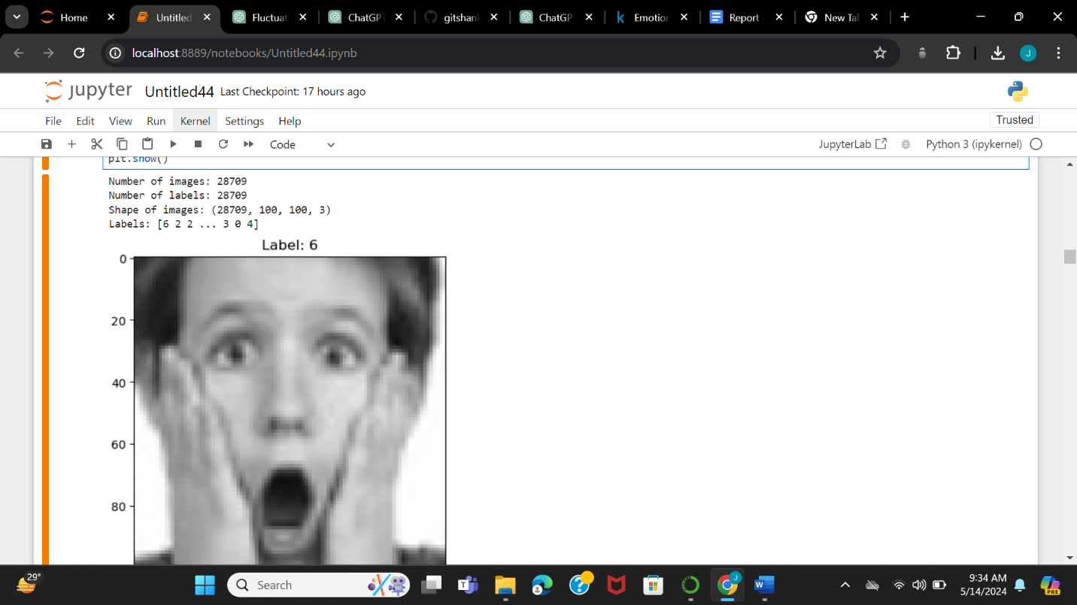

**SHOW NUMBER OF LABELS, IMAGE AND SHAPE**

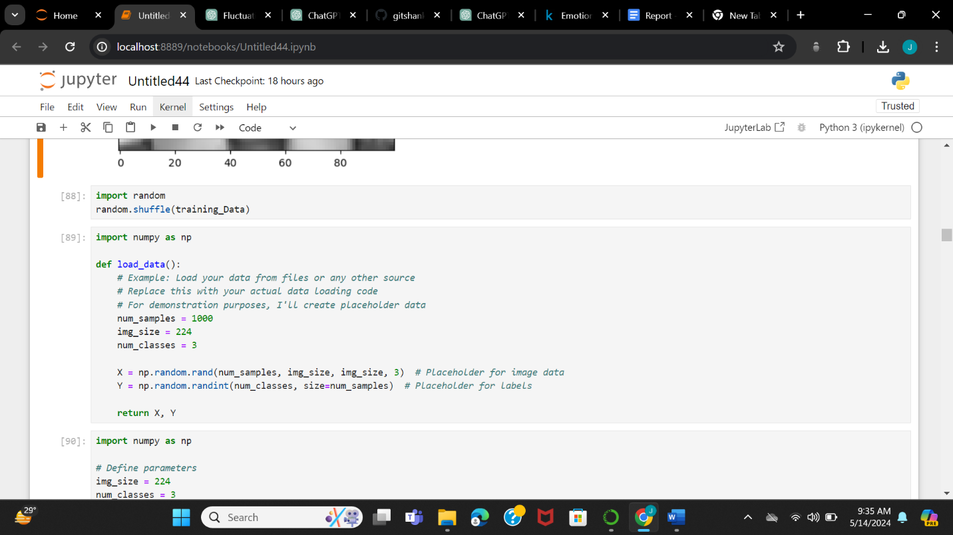

**PLACE HOLDERS FOR DATA AND LABELS**

**RANDOMLY SHUFFLES THE DATA**

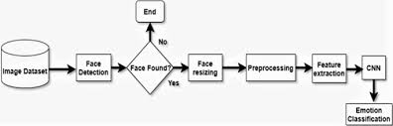

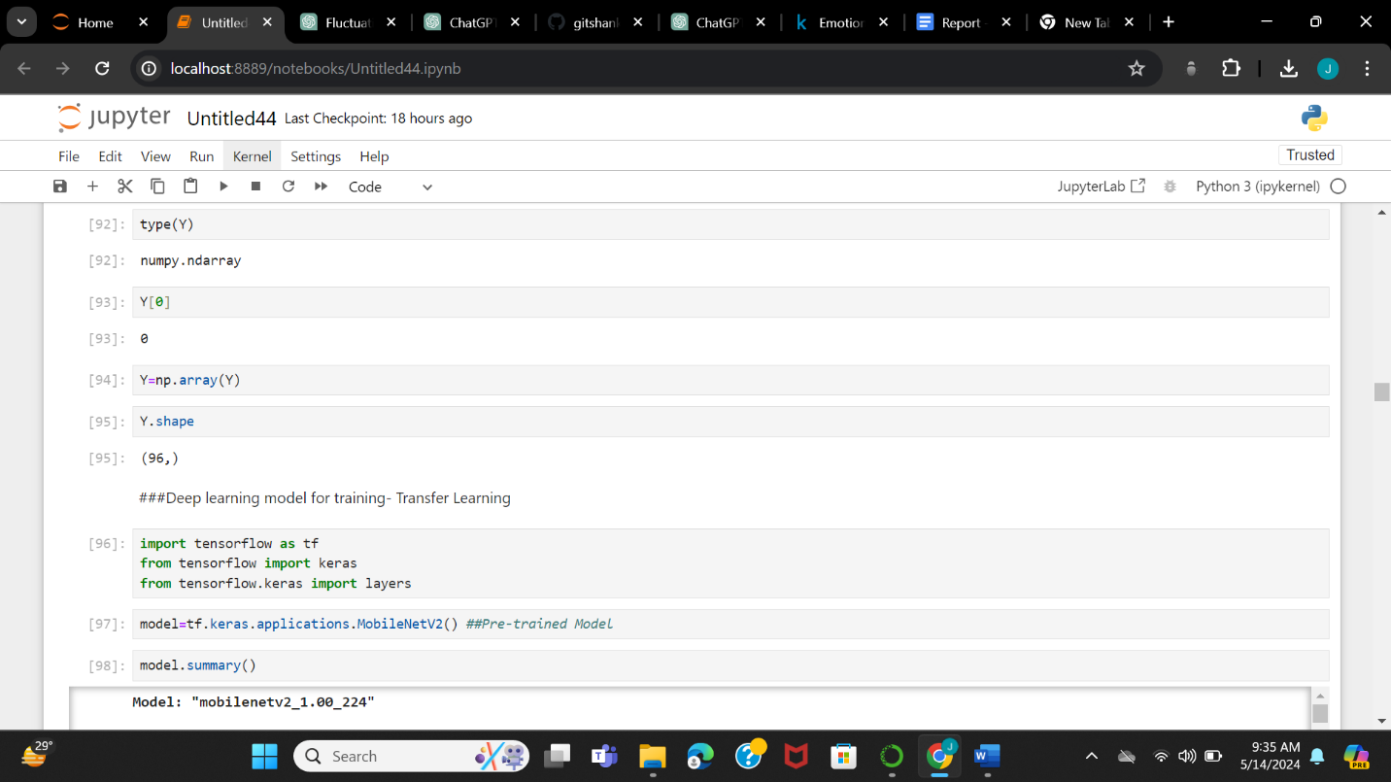

**SHOW THE TYPE OF LABELS**

**PRE TRAINED MODEL**

**CONVERTS FROM LIST TO ARRAY TYPE**

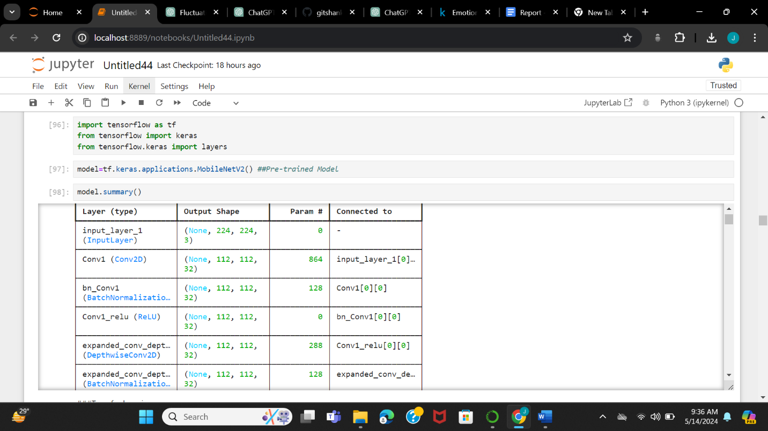

**TELLS TRAINED MODEL SUMMARY**

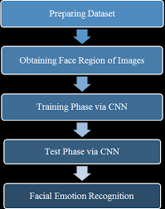

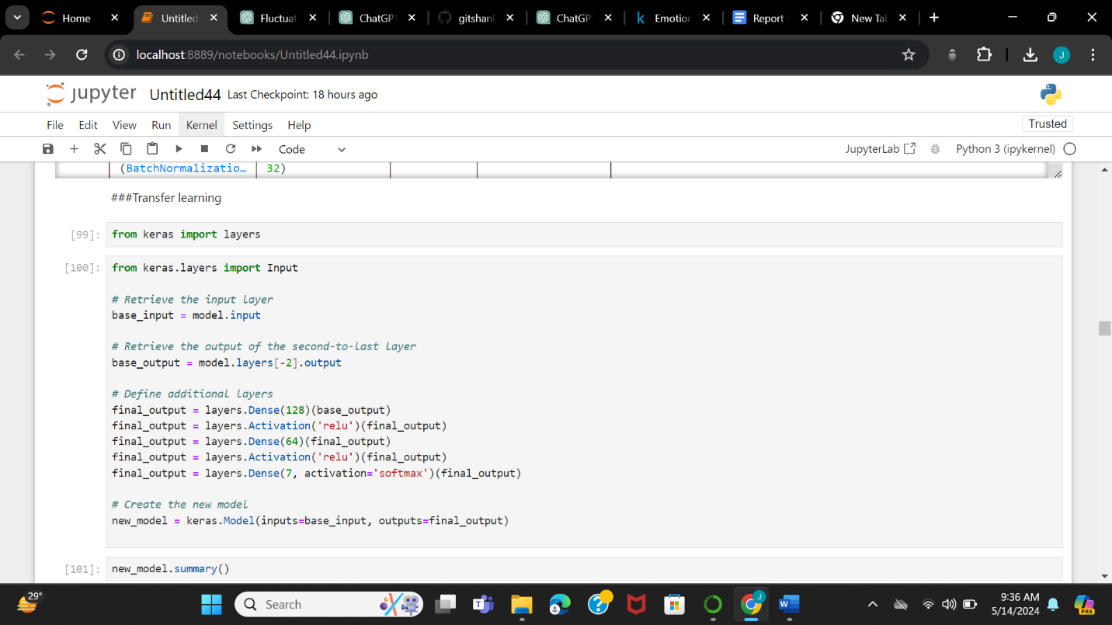

**IT DEFINES A SERIES OF LAYERS IN A NEURAL NETWORK USING A DEEP LEARNING FRAMEWORK, SUCH AS TENSORFLOW WITH KERAS**

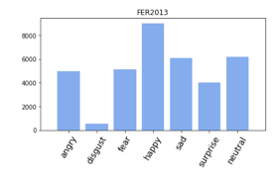

**BARGRAPH OF OUR DATASET**

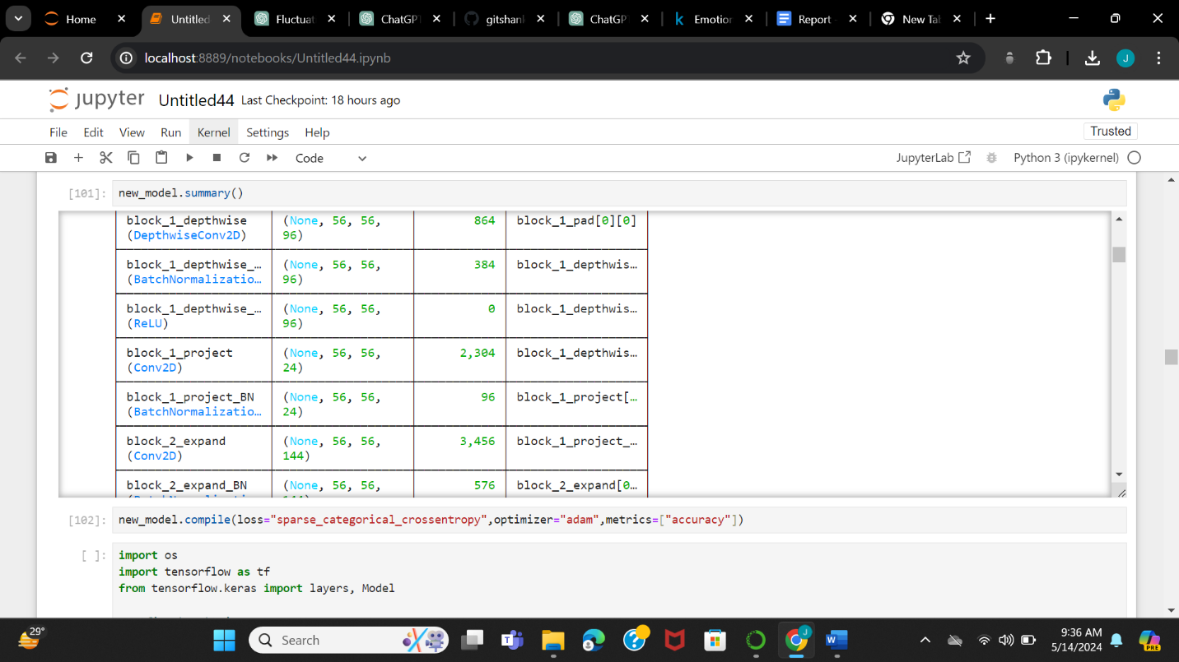

**IT COMPILES THE MODEL AND TELLS US THE ACCURACY**

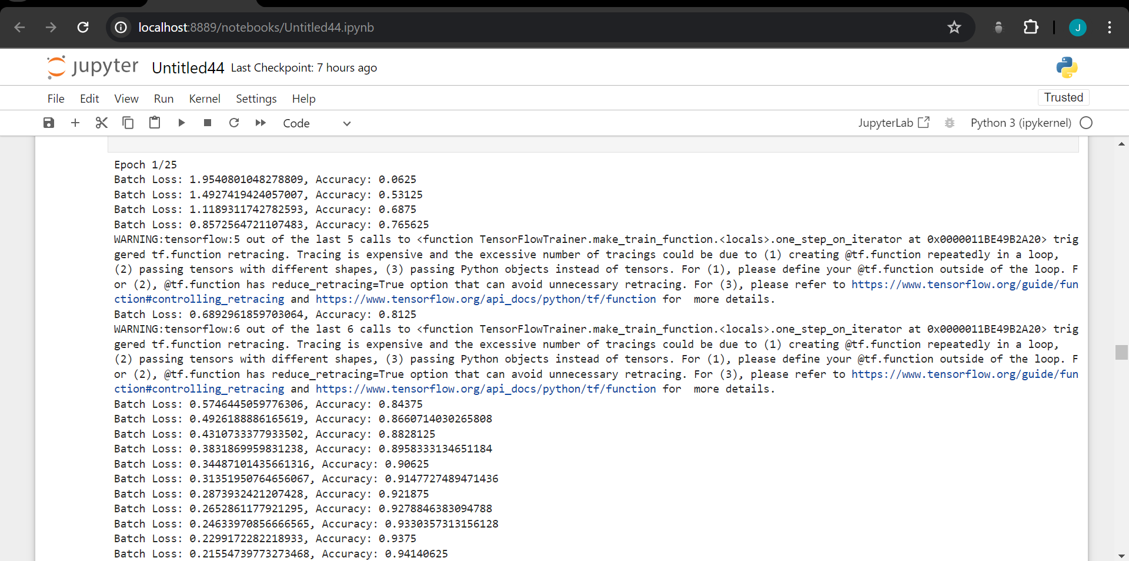

**THIS PICTURE TELLS US ABOUT TH ACCURACY OF THE TRAINED MODEL AND THE BATCH LOSS.**

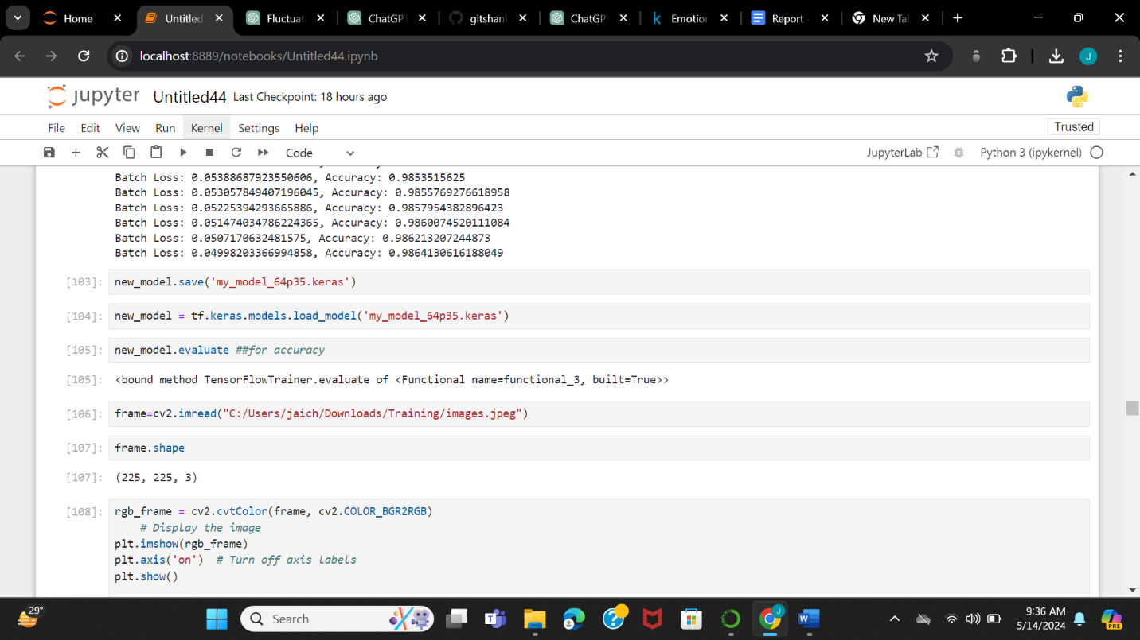

**HELPS US IN TELLING THE SHAPE OF THE MODEL**

**HELPS IN LOADING MODEL INTO INTO A NEW MODEL DATA**

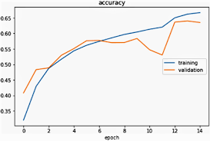

**SHOW’S THE GRAPH OF TRAINING VS VALIDATIOM**



**SHOW US THE IMAGE WITH THE HELP OF “imshow” COMMAND**

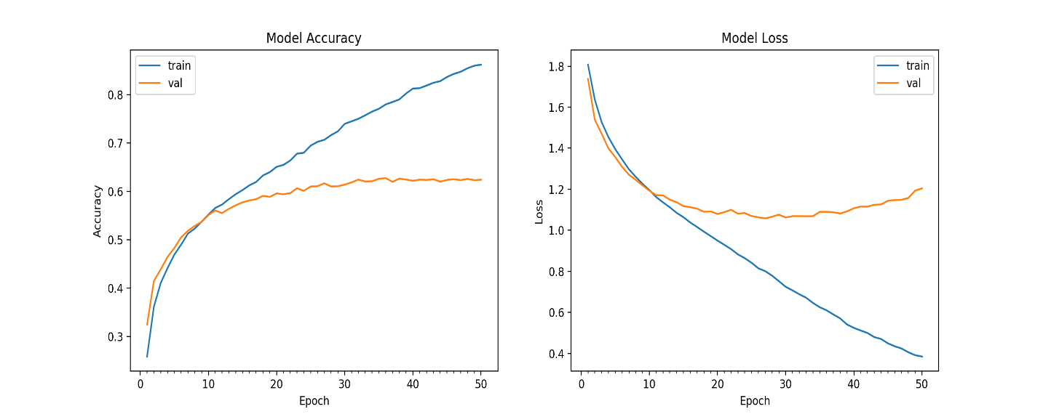

**GRAPHS OF MODEL ACCURACY AND MODEL LOSS**

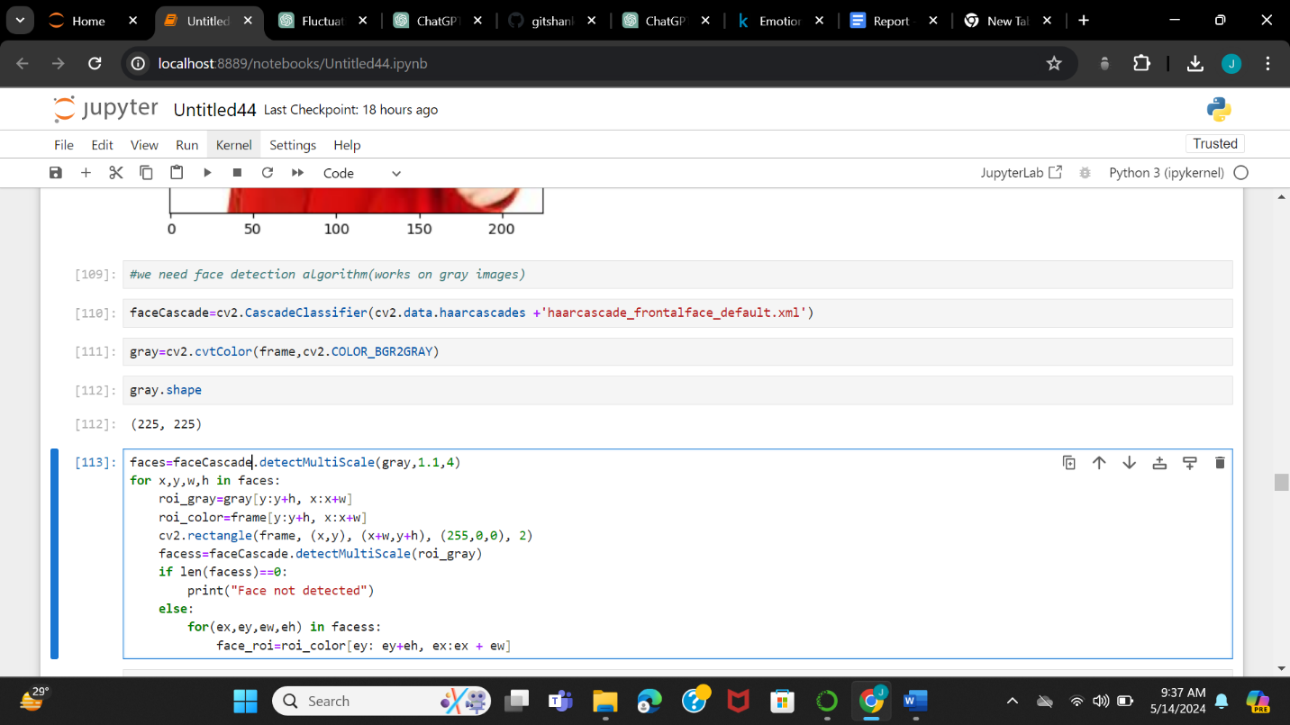

**THE XML FILE HELPS IN LOADING THE FACE RECOGINITION**

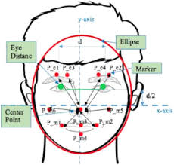

**MATHEMATICAL VIEW HOW IMAGE IS DETECTED**

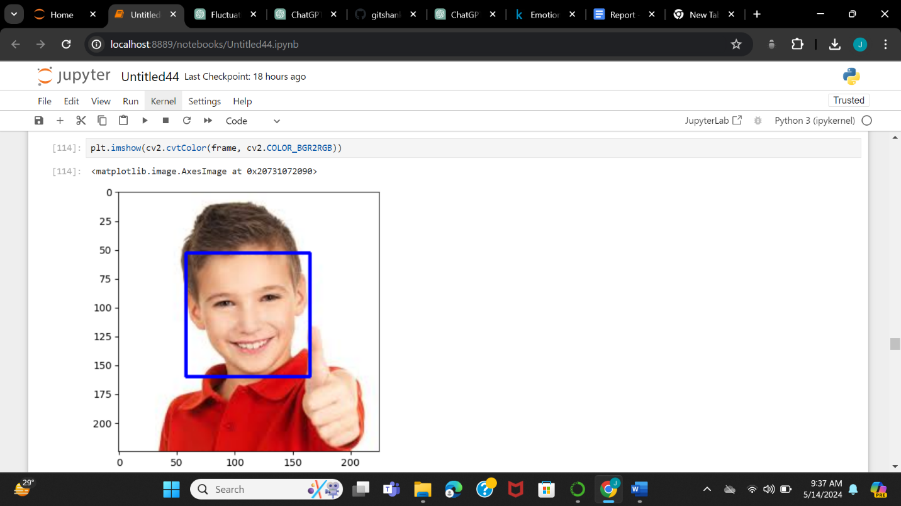

**SHOWS THE IMAGE WITH THE HELP OF “imshow” COMMAND**

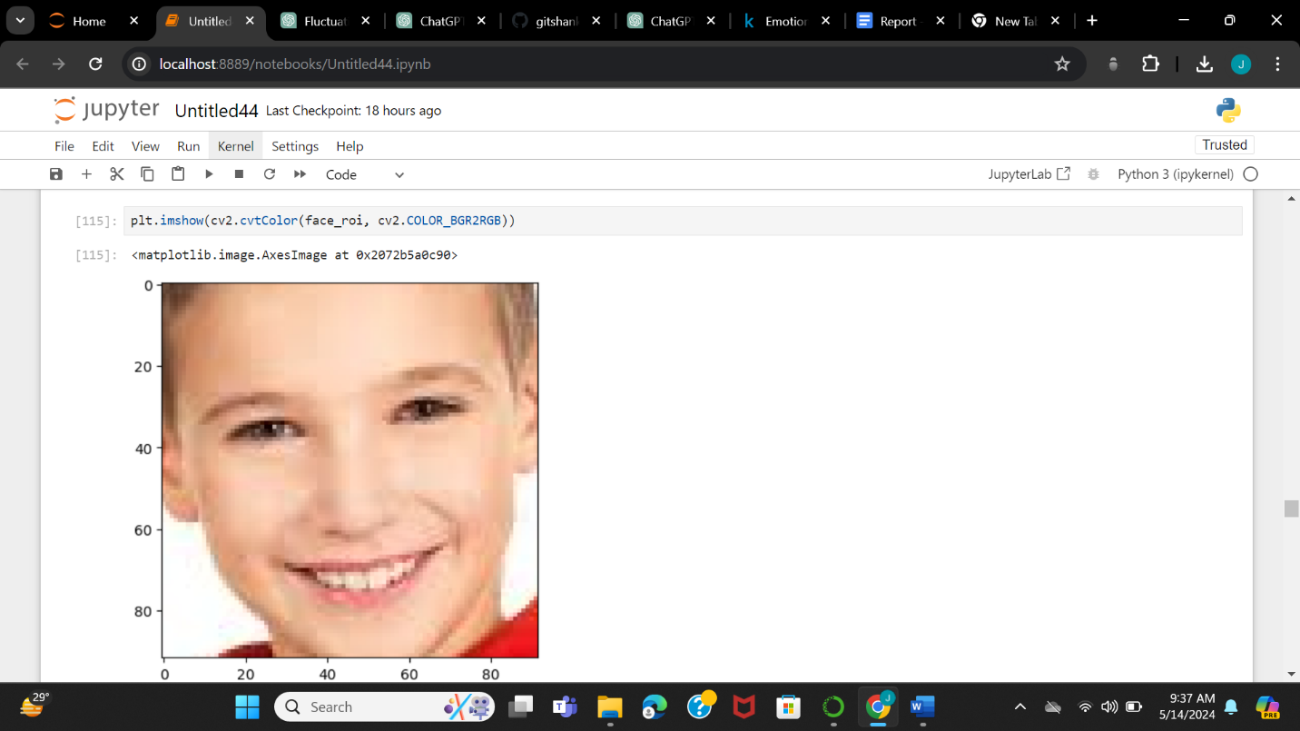

**CLOSE-UP VERSION OF THE PICTURE**

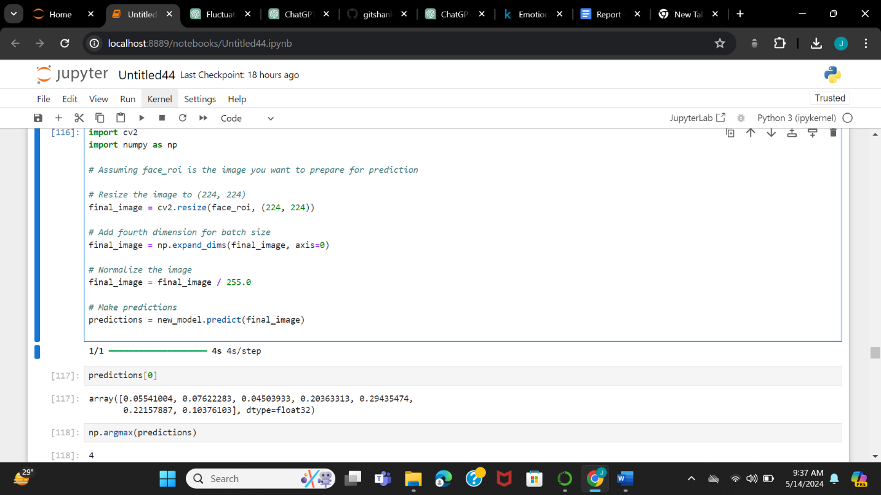

**SHOWS SURPRISE REACTION A PERSON WITH THE HELP OF “imshow” COMMAND**

**PREDICTS THE IMAGES FROM NEW_MODEL**

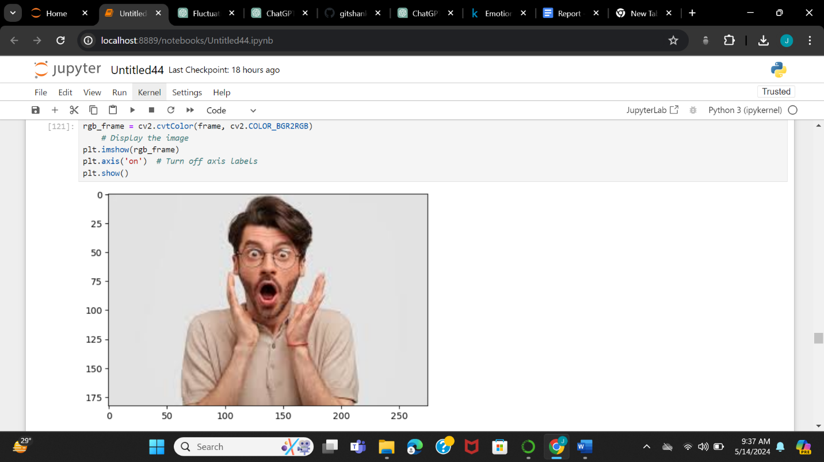

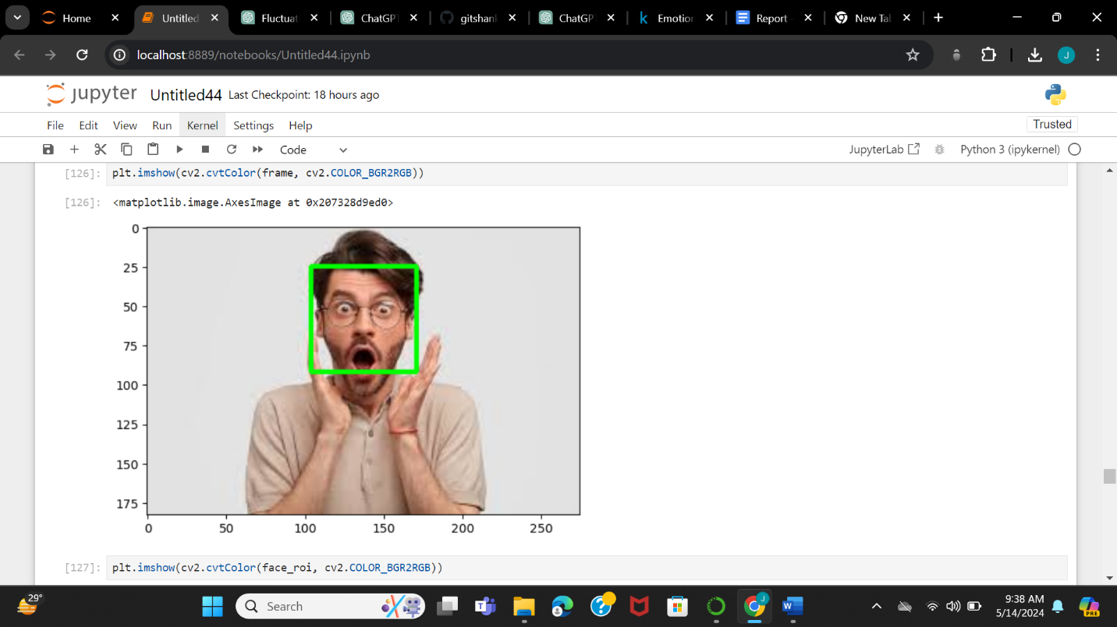

**GREEN COLOUR BOX ON FACE FOR DETECTING FACIAL EXPRESSION OF THE PERSON**

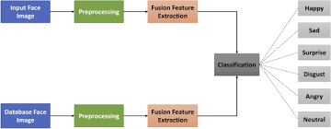

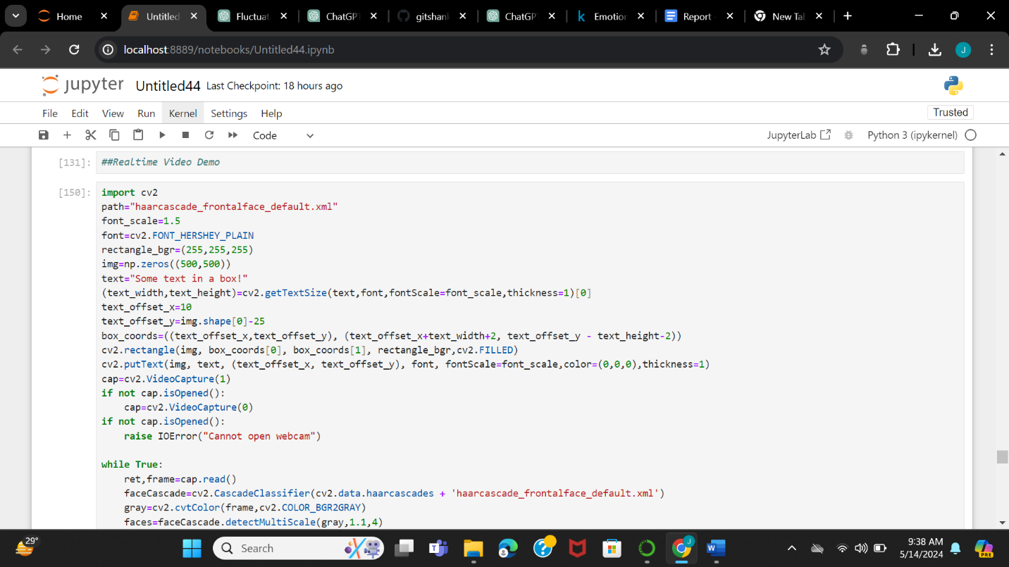

**IMPORTS CV2 LIBRARY AND XML FILE AND COMMANDS IN ORDER TO DETECT FACIAL EXPRESSIONS WHEN WEBCAM GETS OPENED**

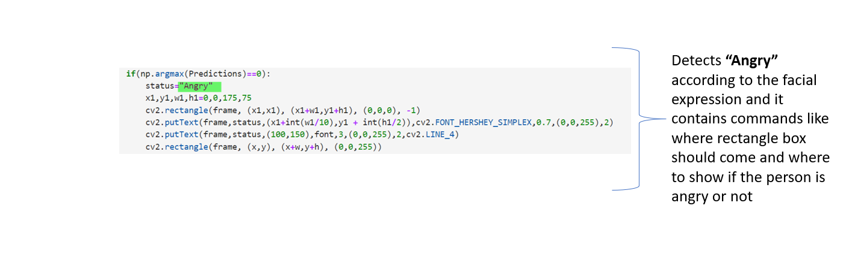

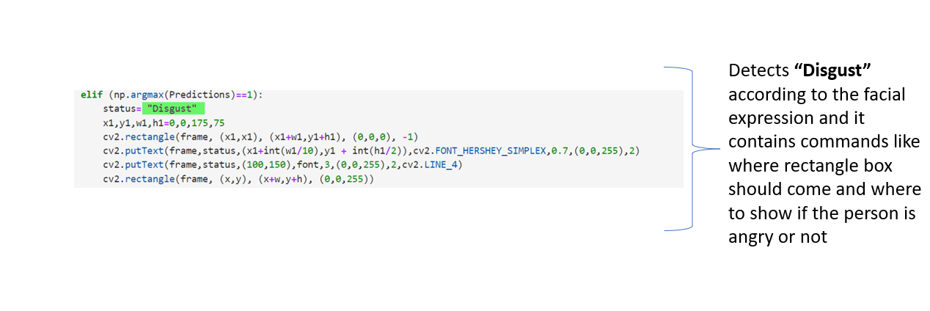

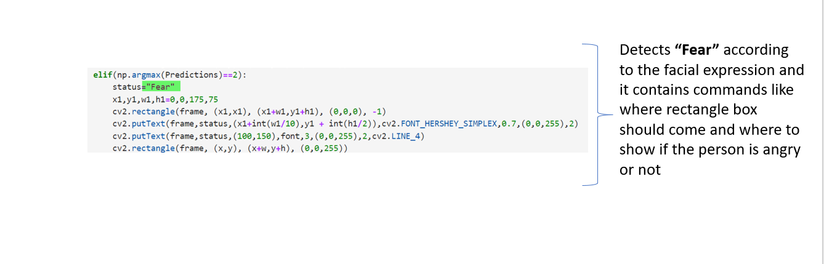

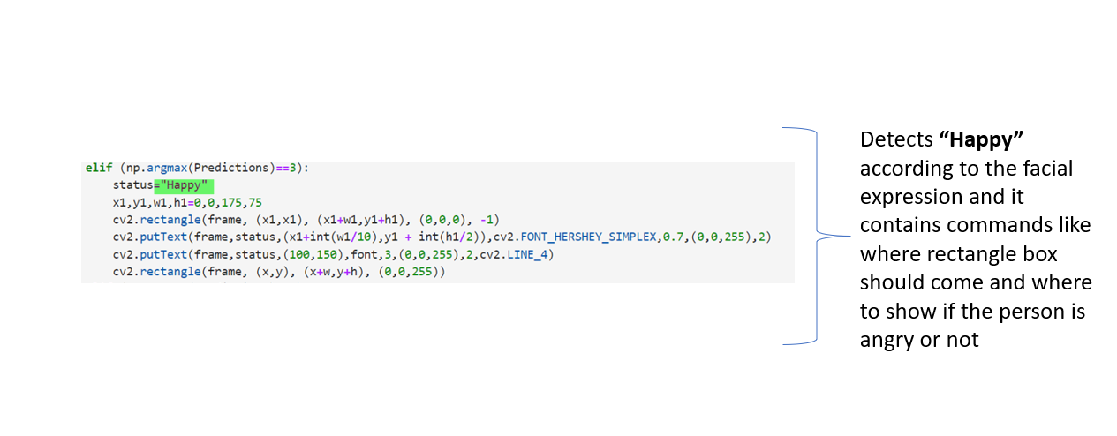

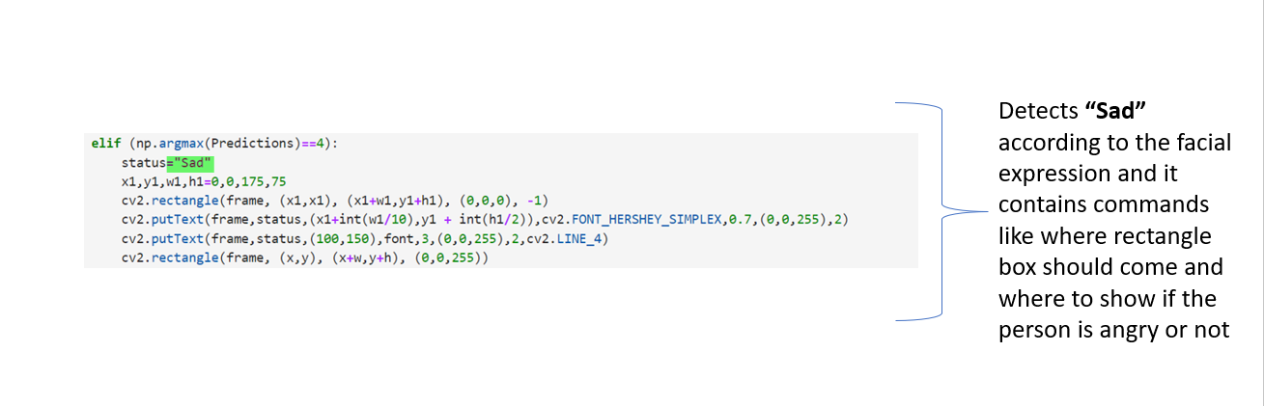

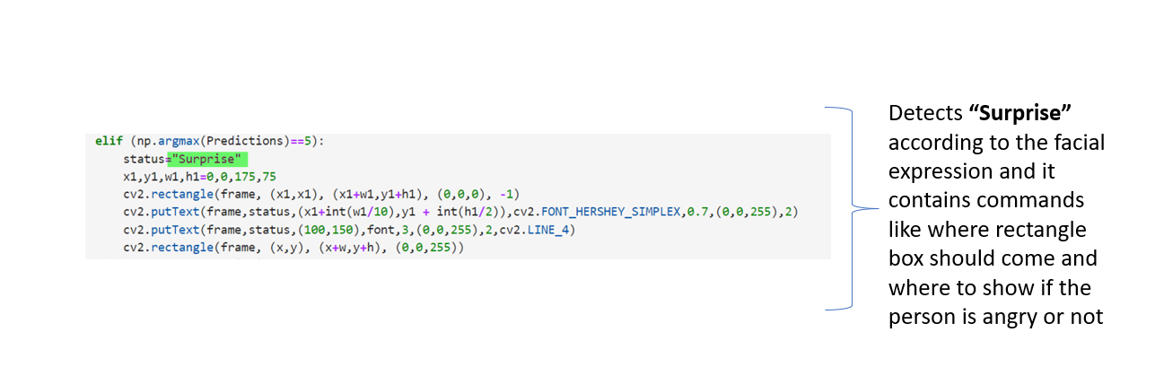

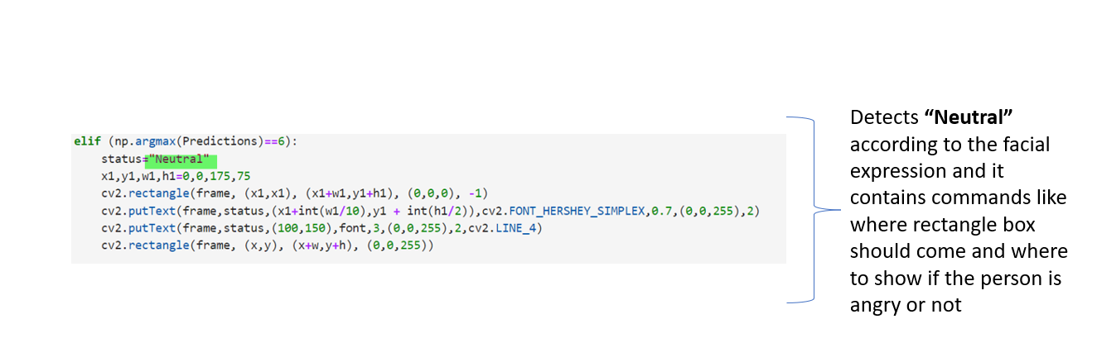

**IN ORDER TO SWITCH OFF THE FRAME PRESS “q” KEY**

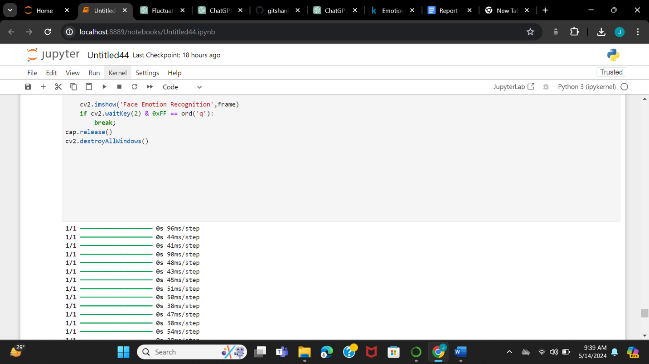

**THIS PART HELPS IN OPENING THE FRAME WHERE WE CAN DETECT OUR FACIAL EXPRESSION**

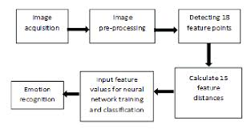

**PROCEDURE FOR DETECTION THE FACIAL EMOTION**

# REFERENCES

Kaggle->

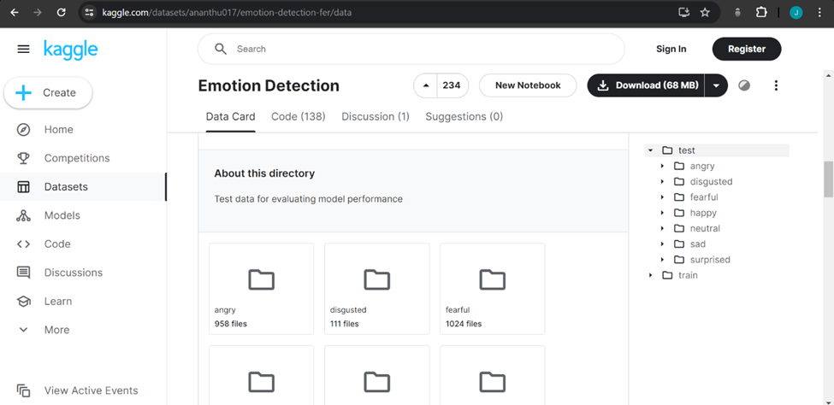

Haarcascades link->

https://github.com/opencv/opencv/blob/master/data/haarcascades/haarcascade_frontalface_default.xml